Included templates:
- Facilitated activity objectives
- Facilitated Activity Script – Conceptual Model Training
- Facilitated Activity #1 Script – Building Conceptual Models
  - Brainstorming factors worksheet
  - Domain worksheet
- Facilitated Activity #2 Script – Creating Research Questions
  - Conceptual models – unique and similar factors worksheet
  - Writing research questions document
- Facilitated Activity #3 Script – Prioritizing Research Questions

INTRODUCTION: This document lists out the goals of each Topic group facilitated activity and should be used when completing the corresponding Activity Logs and Observation Logs to assess whether or not activity objectives were met.

Conceptual Model Training Objectives

- Train Topic group members in terminology and use of path diagrams
  - Participants understand use of path diagrams
  - Participants understand components of path diagrams
  - Participants feel comfortable drafting simple path diagrams

Facilitated Activity #1 Objectives: Building Conceptual Models

Part I: Identifying factors affecting the health outcome
- Topic groups brainstorm a range of potential factors
- Topic groups discuss potential factors and provide examples
- Topic groups agree on a final list of factors related to the health outcome

Part II: Modeling the health outcome
- Topic group add factors to model, while considering whether they are exogenous or mediating factors and whether there are links between factors
- Topic groups sketch diagrammatic model of how determinates are interrelated
- Topic groups include factors in model that reflect group’s personal experience or knowledge, data collected with SCAN participants

Facilitated Activity #2 Objectives: Creating Research Questions

Part I: Review of models
- Topic groups review their model and those of other groups; discuss new factors; highlight important factors

Part II: Training on research question development
- Train Topic groups on research questions and how to develop them

Part III: Question development
- Topic groups prioritize pathways and relationships of interest to generate research questions
- Topic groups propose research questions based on prompts from facilitator

Part IV: Listing questions
- Topic group participants share research questions

Facilitated Activity #3 Objectives: Prioritizing Research Questions

Part I: Prioritization
- Topic groups make use of multi-voting to prioritize research questions

Part II: Making question patient-centered
- Topic groups vote and prioritize remaining research questions according to patient-centeredness criteria:
  - Population
  - Treatment option
  - Study outcomes
  - Timeframe
  - Setting

TOOLKIT INSTRUCTIONS: The included documents provide the instructions, list of materials, and scripts for conducting the following facilitated Topic group activities:

- Conceptual Model Training
- Developing Conceptual Models (Activity #1)
- Creating Research Questions (Activity #2)
- Prioritizing Research Questions (Activity #3)
All of these activities will take place with each of the Topic groups. A facilitator, along with members of the Research Team, are needed to help facilitate and assist with each exercise. Additional supports may be needed for Topic group participants with vision problems or literacy challenges, therefore additional Research Team members should attend these meetings to provide one-on-one assistance to Topic group participants in need of assistance.

Facilitators should be well-versed in all the facilitated activities, therefore it is recommended that facilitators read through the following scripts and training materials several weeks in advance of leading the Topic group meetings. We recommend scheduling each of these activities one week apart – with the exception of ‘Creating Research Questions’ Activity #2 – this should be held TWO WEEKS after ‘Developing Conceptual Models’ Activity #1 in order to allow sufficient time for editing the models in between meetings.

The ‘Conceptual Model Training’ will take approximately 40 minutes to facilitate, while the subsequent three activities will take 3.5 hours. This includes a short break and time for a snack/meal break. We recommend holding these meetings in a space large enough to accommodate the Topic Groups and additional facilitator(s) and Research Team members, along with plenty of space for the group to move about. Ideally, rooms would be equipped with audio/visual equipment to allow for projecting presentations, and a large empty wall to accommodate building each conceptual model. We also recommend providing refreshments for Topic Group members during these long meetings – such as sandwiches, salads, cookies, coffee, etc.

We recommend adapting these tools to fit the goals of your project. Where noted, fill in the [health topic] of focus.

If evaluating these activities, please consult the Evaluation Module for the appropriate tools and instruments to administer, including:

- Facilitated Activity Satisfaction Questionnaire
- Activity Log
- Observation Log
- Meeting Notes template
- After Action Review

Conceptual Model Training (60 minutes)
Facilitator Preparation: We recommend the following resources to familiarize the facilitator and other members of the Research Team with conceptual modeling and how to build path diagrams ahead of leading the Topic Groups through this training:

- https://www.youtube.com/watch?v=2O0gudOnayo
- Zimmerman EB, Woolf SH, Haley A. Understanding the Relationship Between Education and Health: A Review of the Evidence and an Examination of Community Perspectives. In Kaplan R, Spittel M, David D. Population Health: Behavioral and Social Science Insights. AHRQ Publication No. 15-0002. Rockville, MD: Agency for Healthcare Research and Quality and Office of Behavioral and Social Sciences Research, National Institutes of Health; July 2015: 347-384.
- Joffe M, Mindell J. Complex causal process diagrams for analyzing the health impacts of policy interventions. Am J Public Health. 2006;96 (3):473–479. http://dx.doi.org/10.2105/AJPH.2005.063693.
- Paradies Y, Stevens M. Conceptual diagrams in public health research. J Epidemiol Community Health. 2005;59(12):1012–1013. http://dx.doi.org/10.1136/jech.2005.036913.
Materials Needed:
- White board or large wall
- Large Sticky notes
- Dry Erase Markers

Facilitator |  | 20-40 minutes | [Facilitator draws on white board or other large area to illustrate examples.]
Step 1: Introduction to path diagrams:
“Today we are going to be learning how to develop diagrams called ‘conceptual models’ or ‘path diagrams’. These diagrams are pictures we can use to help us organize information and show cause and effect relationships.”
Step 2: Developing a path diagram using ‘Car’ example:
“Let’s say we are interested in predicting whether someone will buy a new car. We’ll call ‘buying a car’ the OUTCOME. Let’s draw a circle at the right and label it ‘buy car’”
[On white board, write ‘Buy a car’ on the far RIGHT side.]
Buy a car

“We use a process called a ‘path diagram’ to map out relationships. We are going to map out the reasons people generally make decisions, or generally do something, such as buy a car. We understand that there are always exceptions to any rule, but today we want to focus on these ideas generally.”
Step 2a: Brainstorming factors
“What are some important reasons someone might buy or not buy a car?” [Facilitator or group member should write each reason on a large sticky note and place on the far LEFT side of board.]
Probe for the following variables :
- Savings/credit
- Condition of old car
- Commuting
- New baby
Probing questions:
- “What else influences whether or not someone will buy a car?”
- “Why might someone choose to buy a car?”
- “Who might be in the market to buy a new car?”
[**The example conceptual model on the last page does not include all the possible factors that predict buying a car. Please adjust as needed and be sure to include the factors your group brainstorms during this step.**]
Step 2b: Developing first path
“Let’s think a little more about SAVINGS/CREDIT… does anything important affect whether someone has good savings/credit to buy a car?”
Probe for:
- Employment or income
“Let’s call Income a PREDICTOR, because it helps predict the OUTCOME (‘BUY A CAR’) and put it all the way on the left side of the model. [Place ‘INCOME’ on left side of board.] Now if income usually causes someone to have better savings/credit, we can draw an arrow from ‘INCOME’ to ‘SAVINGS/CREDIT’. [Draw one-way arrow from ‘INCOME’ to ‘SAVINGS/CREDIT’.] The one-way arrow means that it has some type of impact on where the arrow points. So we call ‘INCOME’ a PREDICTOR and ‘SAVINGS/CREDIT’ a MEDIATOR, because it mediates or comes between the relationship ‘INCOME’ and ‘BUYING A CAR’. This arrow only means probability, not a rule.”
Buy a car
Savings/Credit
Income

[Example of exception – probe for recognition of exception.] “Can you have a good income and bad credit/no savings? Yes. Can you have low income and good credit/good savings? Yes. However, in most cases you will see that as income rises, credit and savings rise too. Now let’s draw an arrow from ‘SAVINGS/CREDIT’ to ‘BUY A CAR’. [Draw one-way arrow from ‘savings/credit’ to ‘buy a car’.] Again, this arrow means probability not a certainty. Can you have good credit and savings, yet still not buy the car? Yes, but chances are, the better your credit and income, the higher the probability that you will buy the car.”
“We now have one path in our diagram.”
Savings/Credit
Buy a car
Income

Step 2c: Incorporating other factors into path diagram:
“Now the diagram becomes more complicated. Let’s think more about each of the other factors we brainstormed. What about CONDITION OF OLD CAR? Does something important come first, meaning, what predicts the condition of your old car?” [Facilitator or group member should write each factor on a sticky note and place in diagram.]
- Probe for income/employment
“What about COMMUTING? Does anything important come first? Is everyone equally likely to commute?”
- Probe for age, rural/urban
- Probe for bidirectional relationships like income and age – “How does age affect a person’s income?”
“When there is no relationship we leave an arrow out. If ‘COMMUTING’ and ‘SAVINGS/CREDIT’ are not related to each other, meaning one doesn’t cause a change in the other, then we don’t need an arrow there.”
“Sometimes we find that variables look related to the outcome we are interested in, but they are really not important at all. Here is an example: a gardening club finds data that people with gardens were more likely to buy cars than people without gardens. Does having a garden cause people to buy cars? Probably not. Another explanation is that people in rural and suburban areas are more likely to have gardens, and are also more likely to buy cars. Where you live (rural, suburban, urban) causes both items to change, but there is no real relationship between having a garden and buying a car. That is called CONFOUNDING. It looks like there is a relationship because both items tend to change (more gardens = more car buying), but that is only because both items are affected by the same thing (where you live).”
Place of residence (urban/suburban/rural)
Buy a car

Have a garden

Step 3: Review the model
“Let’s review all of the paths in the model. Do they make sense? Are the arrows in the right place? Is anything important missing?”
Step 4: Using model to predict who will buy a car:
“Now we have a path diagram. We can use it to make predictions about who would be most likely to buy a car. We can gather data on who buys cars and test which of the paths in the model are strongest (or the most likely to happen), and maybe find that some don’t matter very much after all.”
Discussion questions:
- “What do you think makes this model useful?”
- “If you were selling cars, how would this model affect who you will try to sell a car to? How about where you build a car dealership?”
- “If you were selling cars, would this model help you? Why?”
- “If you were buying a car, would this model help you? Why or why not?”
Facilitator |  |  | [Display sample path diagram in powerpoint. See below for sample diagrams.]
Facilitator and Topic group |  |  | Discuss path diagram and answer questions
Facilitator |  |  | Wrap-up.  [[Optional]: If completing evaluation module, please complete ‘Activity Log’ for Conceptual Model Training. Other evaluation activities include Observation Log, and Facilitated Activity Satisfaction questionnaire.

Sample Path Diagram for Training – Car Example
Garden

Path diagram example #2 – Flu vaccination
Instructions: [Using the same process at outlined above, create a conceptual model where ‘decision to receive/not receive a flu vaccine’ is the health outcome of interest. Use the facilitation questions below to guide the Topic group conversation and generate factors/relationship within the model.]

Facilitation questions to ask for creating conceptual model:
- “What influences whether or not someone will get a flu vaccine? Why might someone choose to get a vaccine or not?”
- “What influences these factors?”
- “How are all these factors related to each other? What relationships exist between these factors?”
[Once path diagram is completed, display sample conceptual model in powerpoint.]

[Use the questions below to generation discussion about the model among the Topic group participants.]

Discussion questions:

- “What do you think makes this model useful?”
- “If you were a public health official trying to encourage more people to get the flu vaccine, would this model help you? How so?”

Sample path diagram – Flu vaccination example
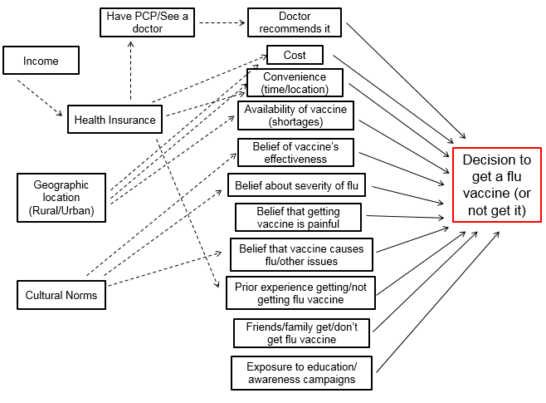

Preparation for Facilitated Activity #1:
- Have the Research Team review the ‘Domain worksheet’ ahead of Facilitated Activity #1 (Building conceptual models) making edits, additions, and deletions as they see fit. This portion of the powerpoint should be updated prior to the next meeting.

TOOLKIT INSTRUCTIONS: The included documents provide the instructions, list of materials, and scripts for conducting the following facilitated Topic group activities:

- Conceptual Model Training
- Building Conceptual Models (Activity #1)
- Creating Research Questions (Activity #2)
- Prioritizing Research Questions (Activity #3)
All of these activities will take place with each of the Topic groups. A facilitator, along with members of the Research Team, are needed to help facilitate and assist with each exercise. Additional supports may be needed for Topic group participants with vision problems or literacy challenges, therefore additional Research Team members should attend these meetings to provide one-on-one assistance to Topic group participants in need of assistance.

Facilitators should be well-versed in all the facilitated activities, therefore it is recommended that facilitators read through the following scripts and training materials several weeks in advance of leading the Topic group meetings. We recommend scheduling each of these activities one week apart – with the exception of ‘Creating Research Questions’ Activity #2 – this should be held TWO WEEKS after ‘Developing Conceptual Models’ Activity #1 in order to allow sufficient time for editing the models in between meetings.

The ‘Conceptual Model Training’ will take approximately 60 minutes to facilitate, while the subsequent three activities will take 3.5 hours. This includes a short break and time for a snack/meal break. We recommend holding these meetings in a space large enough to accommodate the Topic Groups and additional facilitator(s) and Research Team members, along with plenty of space for the group to move about. Ideally, rooms would be equipped with audio/visual equipment to allow for projecting presentations, and a large empty wall to accommodate building each conceptual model. We also recommend providing refreshments for Topic Group members during these long meetings – such as sandwiches, salads, cookies, coffee, etc.

We recommend adapting these tools to fit the goals of your project. Where noted, fill in the [health topic] of focus.

If evaluating these activities, please consult the Evaluation Module for the appropriate tools and instruments to administer, including:

- Facilitated Activity Satisfaction Questionnaire
- Activity Log
- Observation Log
- Meeting Notes template
- After Action Review

Facilitated Exercise 1: Developing Conceptual Models (Total Time = 3.5 hours – Includes 1 break, meal)
IMPORTANT! Prior to activity: Have the Research Team review the ‘Domain worksheet’ ahead of this activity, making edits, additions, and deletions as they see fit. This portion of the powerpoint should be updated prior to this activity.
Materials needed for this activity:

- Large wall or whiteboard
- Large sticky notes
- Large white flip charts – labeled with Domains at top
- Pre-cut sticky ‘arrows’ (if not using whiteboard)
- Pens (1 per person)
- Markers
- ‘Brainstorming factors’ worksheet (1 per person) – see appendix
- Facilitated Activity #1 Powerpoint (includes ‘Domain worksheet’ which will be projected – see appendix)
Introduction
Facilitator | 5 minutes |  | [See script below and use powerpoint presentation as prompt]
“We are here to talk about [health topic]. Everyone here has some experience in this area, and we are interested in learning from your experiences. The purpose of this exercise is to find new ways of looking at what affects [health topic] based on the experiences or knowledge of people like you. Today we will focus on the various factors that you might think affect [health topic]. At a later time, we will get together again to work on developing a list of research questions that you think are most important to study in order to help people with [health topic].
Here are some ground rules for today’s work. First, be aware that there are no right or wrong answers today. Don’t be afraid to speak up or think outside the box. Second, everyone gets a chance to contribute. Third, if people talk about their personal experiences, please respect their right to privacy and do not repeat this information outside this room.
Before we start, I want to thank everyone for participating in this process. As you think about [health topic] today, I want you to think about what you have learned about it personally in your own life or profession. I also want you to think about any data you might have seen regarding [health topic], and finally, please think about the research you did with other people like yourself who have experience with [health topic] and what you learned from them. I’ll give some more instructions in a minute, but does anyone have any questions before we start?”
Topic group |  | 5 minutes | Question/answer

Part I: Identifying factors affecting the health outcome (90 minutes)
Step 1: Brainstorm
Facilitator |  |  |  |  |  |  | [Hand out ‘Brainstorming Factors’ worksheet and pens. See script below.]
“Take a few minutes and write down five to ten things you believe contribute to improve or worsen [health outcome]. These could be anything, from physical health to behaviors to the environment.”(Corresponds to Part 1 on ‘Brainstorming Factors’ worksheet.)
Topic group |  |  | 5 minutes |  |  |  | Stakeholders brainstorm factors with potential causal relationship to [health outcome].
Step 2: Domains: Display domains and order factors
Facilitator |  |  | 5 minutes |  |  |  | [Using a projector, project the ‘Domain’ slide and discuss each of the domains. Next, have stakeholders organize their factors from Part 1 on their worksheet into domains (Part 3 of worksheet). See script below.]
“For this step, go ahead and organize your list into these domains which you’ll see in Part 3 of your worksheet. Domains are categories that group related factors together. In our sessions we sometimes referred to them as ‘buckets’. For example, the domain ‘Health’ may contain factors such as physical health, mental health, diseases, symptoms, etc. The ‘Environment’ domain may contain factors such as the built environment, the natural environment, pollution, climate, etc. You can also create new domains. If you need help placing something into a domain, just let me know and we can figure that out together.”
Topic group |  |  | 5 minutes |  |  |  | [Stakeholders add their ideas from the brainstorming Part 1 to the domains in Part 3 on worksheet.]
Step 3: Adding factors
Facilitator |  |  |  |  |  |  | [Project the slides with domains and additional factors, briefly talking over each factor. See script below.]
“These next slides cover a lot of different domains and things that might affect [health outcome]. Some of these you might have already written down in the previous step. For example, the environment domain may include factors in the environment we live in that might affect our health, from pollutants to the built environment. For this step, read through each of the factors under each domain, and write on your worksheet anything that you’d like to include that you didn’t initially think of when brainstorming.”
Topic group |  |  | 10 minutes |  |  |  | Stakeholders write down items on the worksheet.
Step 4: Fill in domain charts
Facilitator and Topic group |  |  |  |  |  |  | [Ask the group to read out all the factors they listed in Part 3 of the worksheet. These will include both the factors they brainstormed in Part 1, and additional factors they added from the ‘Domains’ powerpoint slides. Have the person who suggested the factor describe briefly why it is important. It should also be emphasized that only the factors that are mentioned in the step will be included in the conceptual model.
Facilitator and Topic group |  |  | 5 minutes |  |  |  | [For each factor added, ask if there is agreement from the group. If not, have the group discuss and come to an agreement about whether it stays or goes. The criteria should be that it may be a predictive factor for at least some persons facing [health outcome], not necessarily all persons. Once agreement is made, write this factor down on a large sticky note and place onto corresponding Domain flipchart page.]  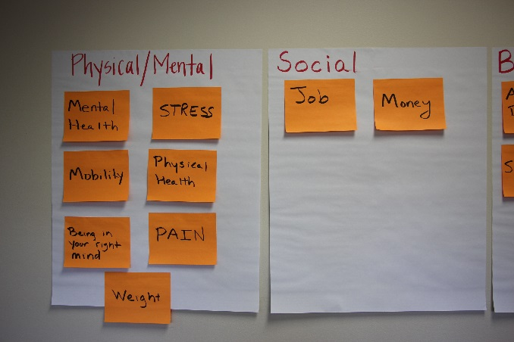  “Does anybody else have anything to add about why this factor is important as a cause of [health topic]?”
 |  |  | 60 minutes |  |  |  | REPEAT across all factors  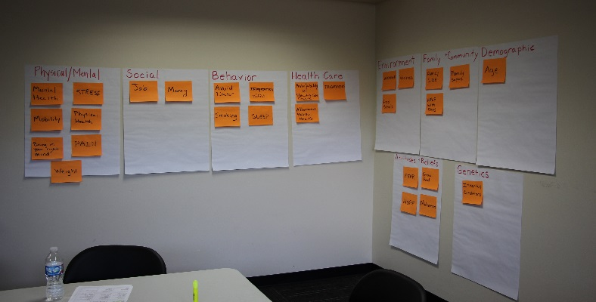
Facilitator |  |  |  |  |  |  | [Once all factors are shared, the group can take a break.]
Part II: Modeling the health outcome (110 minutes)
Introduction
Facilitator | 2 minutes |  |  |  | [See script below]
“Last time we met, we learned how to create path diagrams, which are used to show the cause and effect relationships between two things. We used the example of someone buying a car, and brainstormed ideas for all the reasons why someone might buy a car or might not buy a car, and other factors that might influence this decision. Then we placed them on a diagram and created a path using arrows.
Does anyone have any questions about this activity from last week?”
Step 1: Solicit factors from Topic group
Facilitator |  |  |  |  | [Set up a place for interactive modeling, such as a bare wall, large table, or white board. This will be a hands-on activity for all group members, and will involve moving the large sticky notes from the ‘Domain’ flip charts onto the wall/table/whiteboard where the model is being built]  **Tip! Start with the health outcome all the way to the right of the model.**
“Let’s first draw our dependent variable (the health outcome) on the right, just like in the example. Now, let’s take turns noting the items on our pages that you have highlighted.”
Facilitator |  |  |  |  | [Have someone from the group select one of the factors.]  “OK, now, do we think that goes all the way on the left of our diagram, or does something come first?”
Topic group | 2.5 minutes |  |  |  | Discussion about whether factor is external (not affected by other factors in the model) or is impacted by some factor already in the model.
Facilitator |  |  |  |  | “Does this factor affect something else – is there any other mediating factor between this one and the health outcome?”
Topic group | 2.5 minutes |  |  |  | Discussion about whether factor is a mediator.
Facilitator |  |  |  |  | [Place the factor in the correct spot on the model. This may be to the far left for exogenous factors, somewhere in the middle for mediating factors, or just left of the health outcome if it has a direct effect on the health outcome.]
 | 30 minutes |  |  |  | Continue this process with other factors until all important factors are added to the model. Make sure each participant adds at least one new factor.  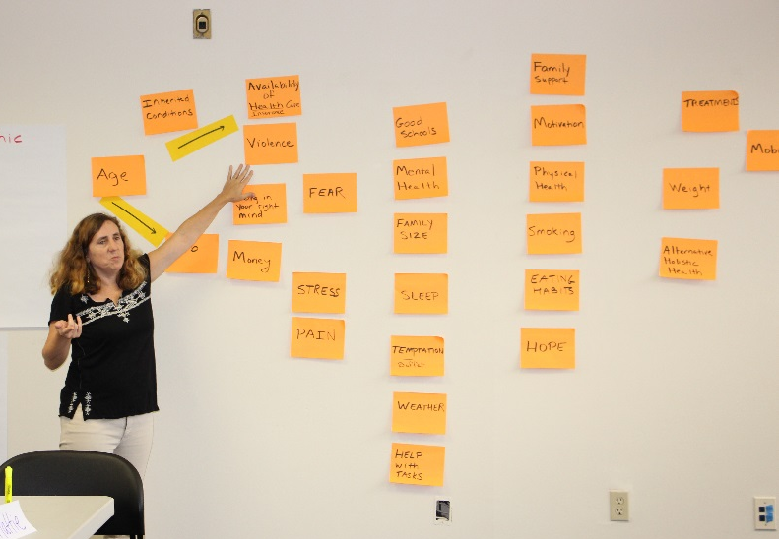
Facilitator |  |  |  |  | “Is there anything missing from the model? Is everything that affects [health outcome] included?”
Topic group | 15 minutes |  |  |  | Discussion and decision about any additional factors.
Step 2: Building the paths
Facilitator |  |  |  |  |  | “In this next part, we’re going to decide how all these things affect each other. We’ll be placing arrows in the diagram to show how these factors relate to one other. We’re going to start on the far left side.”  [Starting with factor on the far left side of model]: “What factor does this directly affect? Can [factor] affect [factors to right]?”  [Place arrows on wall/board/table in between factors as the group discusses the relationship between factors in the model.]  **Example: “Can AGE affect INHERITED CONDITIONS? No, it doesn’t affect the conditions you’re born with. Can AGE affect the kind of JOB you have? Yes, so we’ll put our first arrow from AGE to JOB. What else can AGE affect? The availability of health care? Yes, so we’ll put our second arrow from AGE to HEALTH CARE AVAILABILITY.”**  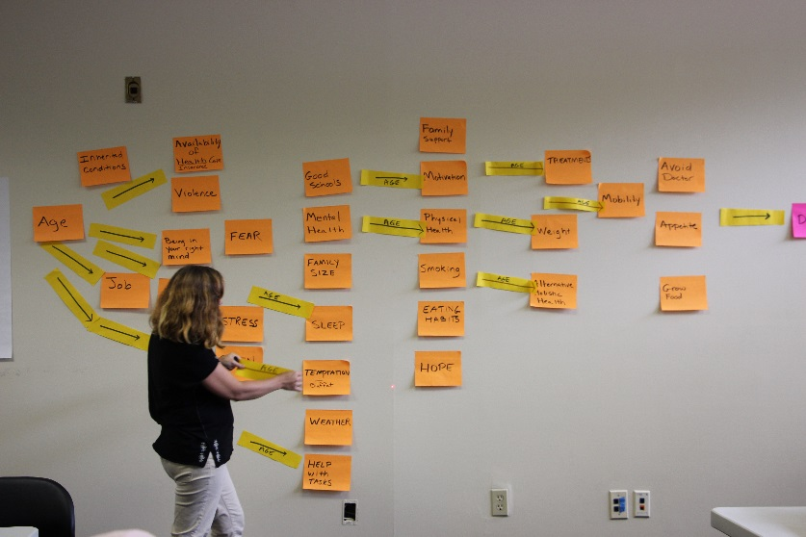  [Make sure to probe group for each factor. Continue this process until all factors and relationships have been discussed.]
Topic group |  | 30 minutes |  |  |  | [Continue adding arrows to model and discussing relationships among factors.]
Step 3: Reviewing the path diagram
Facilitator |  |  |  |  |  | “Let’s see where we stand with this model. Does anything look like it shouldn’t really be here?”
Topic group |  | 15 minutes |  |  |  | Discuss final diagram and come to a decision
Facilitator |  |  |  |  |  | “Have we added all of the arrows we need to add? Let’s look at each item and see if it has a causal relationship with anything else in the diagram.”
Facilitator and Topic group |  | 15 minutes |  |  |  | Review arrows coming to/from each causal factor and discuss potential additions and subtractions.
Facilitator |  |  |  |  |  | [GROUP WRAP UP: Review final path diagram with group]  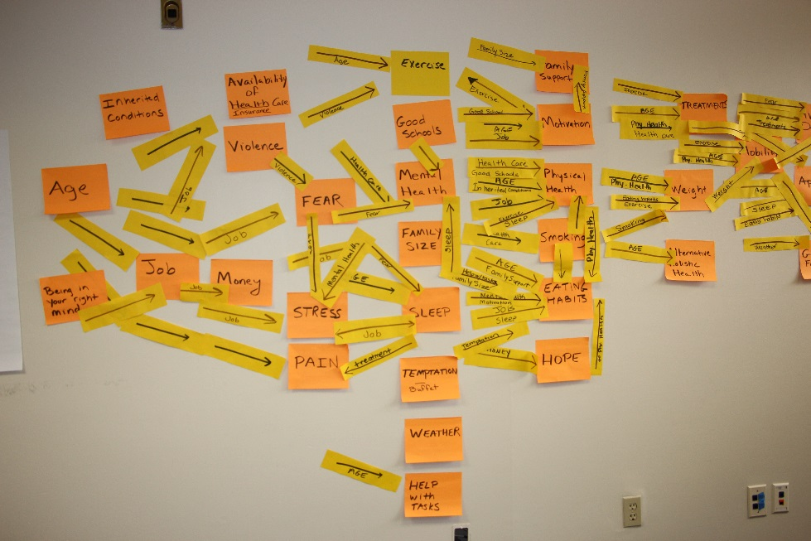  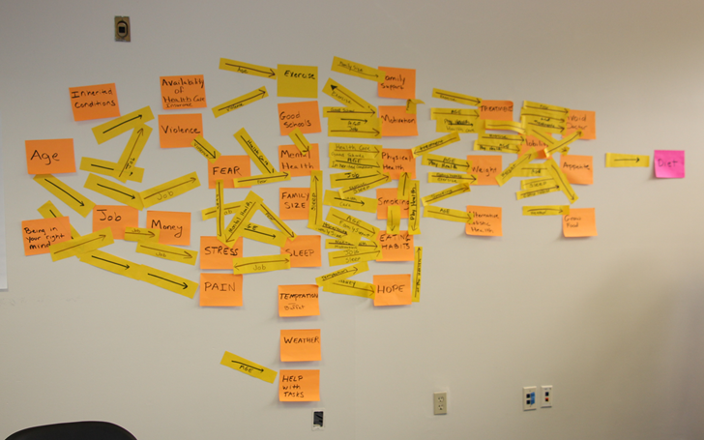  [Carefully document the final path diagram and record the name of the stakeholder group, the facilitator, date and place. (Make sure to take several pictures of the model.) Staple the pages together from each participant and collect those as well.]  [Optional]: If completing evaluation module, please complete ‘Activity Log #1’ for Facilitated Activity 1. Other evaluation activities include Observation Log #1, Facilitated Activity Satisfaction questionnaire, and After Action Review.

Preparation for Facilitated Activity #2:
- Using meeting notes and the photos taken of the conceptual model, create an electronic version of the conceptual models using powerpoint. Factors can be consolidated and groups back into Domains in order to help readability of the model.
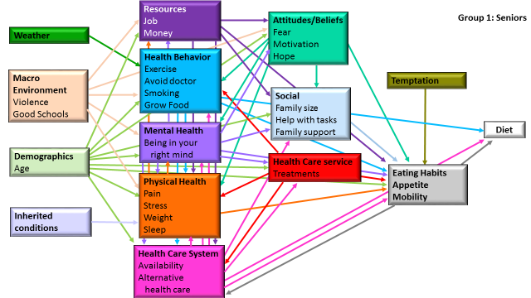

- Create worksheet documenting common and unique factors across all Topic group models.

Instructions: This worksheet will be used to come up with factors that relate, predict, or contribute to [health topic]. These factors will then be organized by domain, and used to build a diagram.

Part 1: Write-down 5-10 things that contribute to [health topic] or make it worse.

1. ________________________________________________________________________________________________________________
2. ________________________________________________________________________________________________________________
3. ________________________________________________________________________________________________________________
4. ________________________________________________________________________________________________________________
5. ________________________________________________________________________________________________________________
6. ________________________________________________________________________________________________________________
7. ________________________________________________________________________________________________________________
8. ________________________________________________________________________________________________________________
9. ________________________________________________________________________________________________________________
10. ______________________________________________________________________________________________________________

Part 2: Facilitators discuss the ‘domains’ listed below and on the powerpoint.

Part 3: Transfer each factors listed above in Part 1 (above) to the appropriate corresponding domain listed below.

Health Environment

Behavior Family/community

Social Demographic

Health care Attitudes/Beliefs

Genetics

Part 4: Facilitators will project other factors organized by domains. Please read through these and write down any additional factors you feel relate, predict, or contribute to [health topic] in Part 3 (above).

TOOLKIT INSTRUCTIONS: The included documents provide the instructions, list of materials, and scripts for conducting the following facilitated Topic group activities:

- Conceptual Model Training
- Developing Conceptual Models (Activity #1)
- Creating Research Questions (Activity #2)
- Prioritizing Research Questions (Activity #3)
All of these activities will take place with each of the Topic groups. A facilitator, along with members of the Research Team, are needed to help facilitate and assist with each exercise. Additional supports may be needed for Topic group participants with vision problems or literacy challenges, therefore additional Research Team members should attend these meetings to provide one-on-one assistance to Topic group participants in need of assistance.

Facilitators should be well-versed in all the facilitated activities, therefore it is recommended that facilitators read through the following scripts and training materials several weeks in advance of leading the Topic group meetings. We recommend scheduling each of these activities one week apart – with the exception of ‘Creating Research Questions’ Activity #2 – this should be held TWO WEEKS after ‘Developing Conceptual Models’ Activity #1 in order to allow sufficient time for editing the models in between meetings.

The ‘Conceptual Model Training’ will take approximately 60 minutes to facilitate, while the subsequent three activities will take 3.5 hours. This includes a short break and time for a snack/meal break. We recommend holding these meetings in a space large enough to accommodate the Topic Groups and additional facilitator(s) and Research Team members, along with plenty of space for the group to move about. Ideally, rooms would be equipped with audio/visual equipment to allow for projecting presentations, and a large empty wall to accommodate building each conceptual model. We also recommend providing refreshments for Topic Group members during these long meetings – such as sandwiches, salads, cookies, coffee, etc.

We recommend adapting these tools to fit the goals of your project. Where noted, fill in the [health topic] of focus.

If evaluating these activities, please consult the Evaluation Module for the appropriate tools and instruments to administer, including:

- Facilitated Activity Satisfaction Questionnaire
- Activity Log
- Observation Log
- Meeting Notes template
- After Action Review

Facilitated Exercise 2: Question Development Guide (3.5 hours – Includes meal and 1 break)
Introduction
Instructions: In this meeting, stakeholders will be developing research questions related to the health topic. We recommend that additional Research Team members are on hand to help Topic group members who may have literacy challenges, vision problems, or difficulty writing – one-on-one may be needed for these participants.
Materials needed for Exercise #2:

- Electronic version of all conceptual models from Facilitated Activity #1 (powerpoint to project)
- Paper copies of all conceptual models (1 per person)
- Conceptual model factor summary handout (1 per person) – see appendix for template
- “Creating Research Questions Training” powerpoint
- Facilitated Activity #2 facilitation powerpoint
- Writing Research Questions document (1 per person) - see appendix for template (this should be adapted)
- Pens (1 per person)
- Highlighters (1 per person)
- Flip Charts
- Markers
Evaluation materials needed (if using Evaluation module):
- Facilitated Activity Satisfaction Questionnaire
- After Action Review Agenda and materials
- Activity Log #2
- Observation Log #1
Facilitator | 5 minutes
“Last time we met we identified factors related to [health topic] and diagramed them in a path model.”
[Display group’s final (edited) path model and hand out copies.]
“Today, we are going to do a few additional steps. We will look back at the path diagram you created along with the path diagrams created by other Topic groups. We will create possible research questions from those models, and choose the most important ones. The selected questions will then be combined with questions selected by the other Topic groups and distributed and published as a research agenda on [health topic]. That will help guide researchers and funders in choosing research projects.”
[Leave time for Questions/Answers from group]
Part I: Review of models (55 minutes)
Materials: Enough copies of all conceptual models; projector with group’s model on slide or powerpoint, highlighters
Facilitator | 30 minutes |  | “Let’s review the model this group created last meeting.”  [Facilitator points out the factors that were identified and how they are related in the model.]  “Now, let’s review the model created by [name of stakeholder group].”  [Hand out copies of this model.]  [Facilitator points out any factor or relationship on the other stakeholder group model that was not present in this group’s model. Also, facilitator points out any differences in the way that relationships were diagrammed.]  Hold off on discussion until all alternative models have been presented.
Facilitator |  |  | Repeat previous step for each additional stakeholder model. Each Topic group will have created one conceptual model.
Topic Group | 20 minutes |  | Discussion of new factors.
Facilitator |  |  | [Facilitator hands out a summary sheet that lists all factors identified across the stakeholder groups and their hypothesized relationships.]  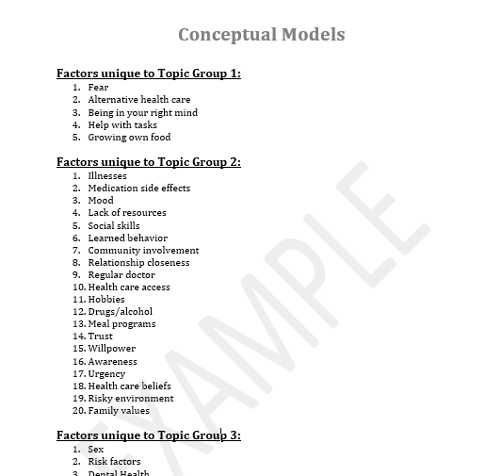
“I want you to take time to review this sheet, which summarizes the factors and relationships that this group and the other stakeholder groups identified. As you read it over, highlight those factors and relationships that you think we need to know more about.”
Topic group | 5 minutes | Individually review the summary sheet.

Part II. Training on research question development (45 minutes w/break)
Instructions: This powerpoint was developed to train Topic group members on research questions and is meant to preface the Question Development activity where stakeholders create their own research questions. This powerpoint can be adapted to fit the needs and experience of your Topic groups, and we encourage the Research Team to seek out any additional training materials that may be of use to the Topic groups during this step.
Materials Needed:
- “Creating Research Questions Training” Powerpoint
[Use the powerpoint to present information about developing good research questions – 30 minutes]

“Research is difficult and expensive and often time consuming and there are limited funds available. A competitive research question has to address an important issue and it must be feasible to design a study to get a clear answer.”
Step 1. | Identify a focus area
Step 2: | Identify a topic
Step 3: | Begin to ask questions about a topic  - Who, what, when, where, why  - Hypothesis, related factors, and testing a hypothesis  - Making questions more specific with when, where, and who
Step 4: | Creating research questions
15 minutes | Break

Part III: Question development (32 minutes)
Instructions: This next part will walk Topic group participants through a series of prompts to create research questions that are of interest and importance to them. The following prompts were used in each of the demonstration sites, however we recommend adapting these to fit the goals of your project, as needed.
Materials Needed:
- ‘Writing Research Questions’ document (1 per person)
- Pens (1 per person)
- Highlighters (1 per person)
- Projector with “Facilitated Activity #2” powerpoint slides.
Introduction
Facilitator | 2 minutes | “We are going to start drafting research questions. As you think about the questions you would ask, you can look at the models created by all of the groups. You can also think about the data you are familiar with, such as which people are most at risk, the theories you are familiar with, and your own personal experiences and those of the other people you heard from.  I am going to provide a series of cues or prompts, and for each prompt I want you to write down at least one research question. You can write as many as you have time for.”
Step 1: Prompt #1 - Causes
Facilitator  Prompt | 5 minutes | “Looking at the models and thinking about what you know about the subject, which pathways are critical to understanding the outcome? Stated another way, “If we really want to know how to improve [health topic], we need to better understand the relationship between X and Y.” Now, you have to decide what X and Y are, and remember, they can be anywhere on the model, not just factors that lead directly to [health topic].”  [Display the prompt question.]  “Remember to write at least one question, and you can write as many as you have time for.”
Topic Group |  | [Write down their questions.]
Step 2: Prompt #2 - Impact
Facilitator  Prompt | 5 minutes | “Looking at the models and thinking about what you know about the subject, which pathways are most likely to respond to intervention? Stated another way, if we could change factor X it would likely have a strong effect on [health topic]. Remember, the strong effect you are thinking of might directly affect [health topic], or it might affect another factor in the path.”  [Display the prompt question.]  “Remember to write at least one question, and you can write as many as you have time for.”
Topic Group |  | [Write down their questions.]
Step 3: Prompt #3 - Patient-Centeredness
Facilitator Prompt | 5 minutes | “Looking at the models and thinking about what you know about the subject, what questions if we answered them would help patients with [health topic] make more informed decisions? Stated another way, if we could answer this question, patients would have better information for choosing treatments or for making other types of decisions.”  [Display the prompt question.]  “Remember to write at least one question, and you can write as many as you have time for.”
Topic Group |  | [Write down their questions.]
Step 4: Prompt #4 - Verification
Facilitator  Prompt | 5 minutes | “Looking at the models and thinking about what you know about the subject, are there relationships in the model that are promising but we need to know more about? Stated another way, is there something you believe that needs to be proven for a fact? Do we need more evidence to show that a particular cause is important or that a promising treatment is effective?”  [Display the prompt question.]  “Remember to write at least one question, and you can write as many as you have time for.”
Topic Group |  | [Write down their questions.]
Step 5: Prompt #5 - New Directions
Facilitator  Prompt | 5 minutes | “Looking at the models and thinking about what you know about the subject, what is a new way of thinking about [health topic]? This is the time to think outside the box. Is there something important as a cause or solution that is missing or misunderstood in these diagrams? If stated another way, is there something here we know very little about right now?”  [Display the prompt question.]  “Remember to write at least one question, and you can write as many as you have time for.”
Topic Group |  | [Write down their questions.]
Step 6: Highlight questions
Facilitator | 5 minutes | “Take a few minutes to read over all of the questions you have written down, highlighting the ones you think are most important.”
Topic Group |  | Highlight questions.

Part IV: Listing Questions (50 minutes)
Instructions: In this next steps, participants will share the research questions they created that they feel are most important. They will be asked to share that question and provide an explanation about why they feel the question should be included. As each stakeholder shares a question – write this on a large flip chart, along with the name of the participant that developed the question. This is also a time when facilitators can probe for additional information to help stakeholders think through their terms and clarify the meaning of their question. It is important to keep detailed records of these steps and the questions that are generated in this meeting, therefore we recommend taking notes during the meeting as well as photographing each of the flip charts containing the questions. Participant’s worksheets should also be collected.

[We recommend the Project Coordinator types up each question into a word document/meeting notes as each question is being added to a sticky note. Each question should include the Topic group member’s name that proposed the question, and their explanation for including the question. This information will help provide context to the final question in the Literature Review/Question Refinement step.]
Step 1: Listing questions
Facilitator | 2 minutes | “We are going to go around the room and take turns reading off our research questions we highlighted. When it is your turn, read a question from your list that you think is most important and give a brief explanation of why you think it is important. We’ll come back around until everyone has had a chance to read out all their questions or we run out of time”.
Topic group | 45 minutes | [Have group take turns reading off their research questions and providing an explanation. Each person can give one question in each round, but the group can add as many questions to the list as there is time for. Each person will have time at the next meeting to review their questions and provide a brief explanation for why they included it. Make sure to probe for additional information as needed, to clarify the nature of the question and the terms used. This can be a first step to ‘wordsmithing’ each question.]  [Write each of these questions on white flip chart with name of Topic group member who provided the question. **Tip! Bring these flip charts back next week!**]
Step 2: Wrap Up
Facilitator | 3 minutes | “Great! When we meet during our next meeting, we’ll take turns reading off our research questions again, but will also allow time for you to provide a brief explanation for why you included it as a question. We will also walk through some steps on deciding which are the most important questions to include. Please pass forward the worksheets you wrote your questions on as we will be collecting these.”  [Optional]: If completing Evaluation Module, please complete ‘Activity Log #2’ for Facilitated Activity 2. Other evaluation activities include Observation Log #2, Facilitated Activity Satisfaction questionnaire, and After Action Review.

Preparation for Facilitated Activity #3:
- Using meeting notes and the photos taken of the research questions, number and transfer these questions to a Word document. The research questions should be categorized by Topic group. Topic groups will only be working with their own set of research questions, not the questions generated by other Topic groups.
- Modify powerpoint to include Topic group questions.
- Decide on the final number of research questions desired (per Topic group) – this will be the number of questions prioritized in Facilitated Activity #3.

Conceptual Models: Unique and Similar Factors

Instructions: Fill in factors only occurring in each of the Topic groups, and factors that are similar across two or more Topic groups. Fill in additional lines and sections as needed.

Factors unique to Topic Group 1:
1.
2.
3.
4.
5.

Factors unique to Topic Group 2:
1.
2.
3.
4.
5.

Factors unique to Topic Group 3:
1.
2.
3.
4.
5.

Factors in two or more models:
1.
2.
3.
4.
5.

Factors in all three models:
1.
2.
3.
4.
5.

Name: _____________________________________________________________________________

Step 1: Causes [ADAPT IF NEEDED]

Step 2: Impact [ADAPT IF NEEDED]

Step 3: Patient-Centeredness [ADAPT IF NEEDED]

Step 4: Verification [ADAPT IF NEEDED]

Step 5: New Directions [ADAPT IF NEEDED]

TOOLKIT INSTRUCTIONS: The included documents provide the instructions, list of materials, and scripts for conducting the following facilitated Topic group activities:

- Conceptual Model Training
- Developing Conceptual Models (Activity #1)
- Creating Research Questions (Activity #2)
- Prioritizing Research Questions (Activity #3)
All of these activities will take place with each of the Topic groups. A facilitator, along with members of the Research Team, are needed to help facilitate and assist with each exercise. Additional supports may be needed for Topic group participants with vision problems or literacy challenges, therefore additional Research Team members should attend these meetings to provide one-on-one assistance to Topic group participants in need of assistance.

Facilitators should be well-versed in all the facilitated activities, therefore it is recommended that facilitators read through the following scripts and training materials several weeks in advance of leading the Topic group meetings. We recommend scheduling each of these activities one week apart – with the exception of ‘Creating Research Questions’ Activity #2 – this should be held TWO WEEKS after ‘Developing Conceptual Models’ Activity #1 in order to allow sufficient time for editing the models in between meetings.

The ‘Conceptual Model Training’ will take approximately 60 minutes to facilitate, while the subsequent three activities will take 3.5 hours. This includes a short break and time for a snack/meal break. We recommend holding these meetings in a space large enough to accommodate the Topic Groups and additional facilitator(s) and Research Team members, along with plenty of space for the group to move about. Ideally, rooms would be equipped with audio/visual equipment to allow for projecting presentations, and a large empty wall to accommodate building each conceptual model. We also recommend providing refreshments for Topic Group members during these long meetings – such as sandwiches, salads, cookies, coffee, etc.

We recommend adapting these tools to fit the goals of your project. Where noted, fill in the [health topic] of focus.

If evaluating these activities, please consult the Evaluation Module for the appropriate tools and instruments to administer, including:

- Facilitated Activity Satisfaction Questionnaire
- Activity Log
- Observation Log
- Meeting Notes template
- After Action Review

Facilitated Exercise 3: Question Prioritization Guide (3.5 hours – includes 1 break and meal)
Materials Needed:
- Facilitated Activity #3 powerpoint slides
- Whiteboard or flipchart to record and display prioritized questions
- Large supply of pre-cut paper ballots (small sticky notes or note cards)
- Pens or pencils (1 per person)
- Copies of Topic Group questions (1 per person)
- Flip charts from last meeting (Facilitated Activity #2) with Topic group’s question
Introduction
Instructions: In this step (Part I, Step 1), Topic groups will be reviewing the questions their group created and shared during the last facilitated activity (#2). We recommend displaying their questions on the flip charts used in the last meeting. We also suggest numbering and typing up these questions in a word document to pass out to the Topic group, as well as projecting these questions in the powerpoint slides). Topic group members will be given a chance to read through each question and provide an explanation to the questions they proposed during the last meeting, as well as add any additional questions they’d like to the list. The next step (Part I, Step 2) will involve stakeholders voting on their top favorite questions (prioritization) through a multi-voting method. *Facilitators should decide ahead of this meeting how many final research questions they’d like to end up with at the end of this meeting.* There may be multiple rounds of voting to get to this final number of questions – this depends on the number and quality of questions at the start of the voting, and how strongly favored they are by the group. Continue voting until the Topic group has reached the final desired number of questions. The last step (Part II) will involve making the prioritized set of research questions more specific and patient-centered.

[In Part II, we recommend the Project Coordinator types up each prioritized question into a word document/meeting notes as each question is made more specific and patient-centered. Each question should include the original wording and the group’s discussion around making it more specific. This information will help provide context to the final question in the Literature Review/Question Refinement step.]
“When we met last time, we went around the group and read off research questions we had developed during our meeting. Today, we’ll have a chance to re-visit those same questions and again provide an explanation for why you included it as a question.”
Part I: Prioritization ( 70-80 minutes)
Step 1: Listing questions
Topic group | 45 minutes | [Group should take turns with each person reading off their research questions and giving brief explanations. Each person can give one question in each round, but the group can add as many questions to the list as there is time for.]

Step 2: Multi-voting
Facilitator | 3 minutes | [Hand out paper ballots to each stakeholder. The number of ballots should equal one-third of the number of questions on the list.]  [**For example, if there are 18 questions on the list, each participant should receive 6 ballots. They will cast a total of 6 votes (1 ballot = 1 vote) for their top favorite questions they’d like to carry over to the final step. Continue distributing ballots (one-third of the number of questions on the list) until the group has reached the final desired number of questions.**]  “Now I want you to use these ballots to vote on the questions in the list. You must use all of your ballots and you may only vote for a question one time. Write the number of each question you are voting for on one of these ballots. Vote for the questions you think are most important.”
Topic Group | 5 minutes | Vote and turn in their ballots (Round 1 of voting).
Facilitator | 7 minutes | [Tally the votes. Cross out items that have:  - Two or fewer votes if the group has 5 or fewer members  - Three or fewer votes if the group has 5 to 15 members  - Four or fewer votes if the group has more than 15 members]  [Count the number of questions remaining. Each person again gets the number of ballots equal to one-third of the number of items remaining on the list.]
Topic Group | 5 minutes | Vote and turn in their ballots.
Facilitator/ Topic Group | 10-25 minutes | Repeat voting procedure until there are about [desired number] questions remaining.
Facilitator |  | Document complete list of questions that were selected after voting. If using Evaluation Module, can document on ‘Activity Log 3’.

Part II: Making research questions patient-centered (70 minutes)
Facilitator | “We are going to focus our questions a bit more on defining the populations and outcomes that should be address in the research questions. Let’s go through our final list of questions to narrow down some of the needed elements.”  POPULATION:  “Let’s start with question one. First is the population. Who should be included as research participants? If you were designing a study to answer this question, are there people you would almost certainly want to be part of that study? Are there people you think should not be part of that study, at least not yet?”
Topic Group |  | Discussion – group comes to a consensus about most popular options

Facilitator | OUTCOMES:  “Patient centered research requires the use of study outcomes that matter to patients, outcomes that they notice and find meaningful. Examples might be measures of symptoms, such as pain or nausea, or measures of function, such as mobility or continence. What outcomes would be most meaningful to patients? What should researchers measure?”
Topic Group |  | Discussion – group comes to a consensus about most popular options
[Optional prompts: We recommend using the following additional prompts with more experienced Research Teams only.]
Facilitator | [If the question is about a treatment option or intervention].  TREATMENT:  “What should we compare the treatment we are interested in to? For example, if we were looking at treatment for arthritis, we might compare one type of pain medication to another type of pain medication.”
Topic Group |  | Discussion – group comes to a consensus about most popular options
Facilitator | TIMEFRAME:  “What timeframe would be best for patients to look at outcomes? What about follow up?  For example, should we follow people in this study for a month? A year? How long does it take to get meaningful answers?”
Topic Group |  | Discussion – group comes to a consensus about most popular options
Facilitator | SETTING:  “What settings should this research take place in? For example, should we look at treatment as outpatients, in hospitals, somewhere else?  For example, if the study tests a new exercise program, should the study take place with hospitalized patients, patients attending a clinic, at a community center, or should people do the exercise program at home?”
Topic Group |  | Discussion – group comes to a consensus about most popular options
***Repeat steps for the rest of the research questions, spending 10-20 minutes on each research question; Adjust time as needed depending on the number of final research questions in list***

Wrap-up
Facilitator [Review final set of questions that were voted on.]

[Re-cap the project and each facilitated exercise, and what the next steps are with these research
questions. Make sure to thank stakeholder for their time and participation.]
Facilitator [Make sure to document the final set of research questions. It is also recommended that photos are taken of each of the flipcharts that questions were written down on.]

[Optional]: If using Evaluation Module, please complete ‘Activity Log #3’ for Facilitated Activity 3. Other evaluation materials include Observation Log #3, Facilitated Activity Satisfaction Questionnaire, and After Action Review.

